**Task 1.1 - > Zenity Commands Explorer in Linux**

**Link to the blog ->** [**Task 1.1**](https://hollowescape.blogspot.com/2021/09/zenity-commands-explorer-in-linux.html)

**Documentation :->**

1. **Zenity Command: -** is a program that will display GTK+ dialogs, and return (either in the return code, or on standard output) the users input. This allows you to present information, and ask for information from the user, from all manner of shell scripts.

**Zenity Command comes with many options which are as follows:-**

* Zenity --about command

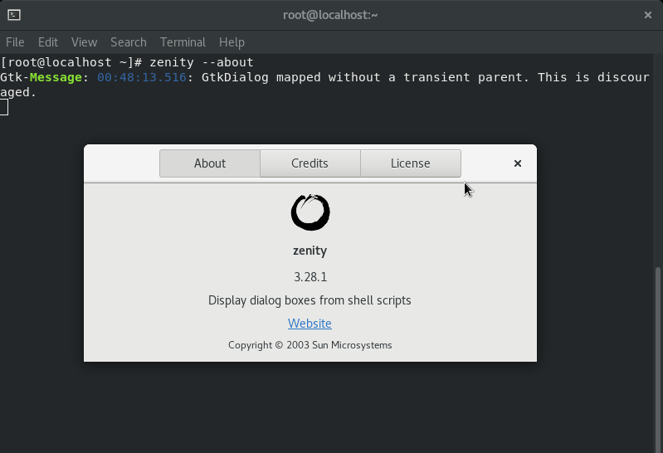

* Show the calendar using the zenity Command

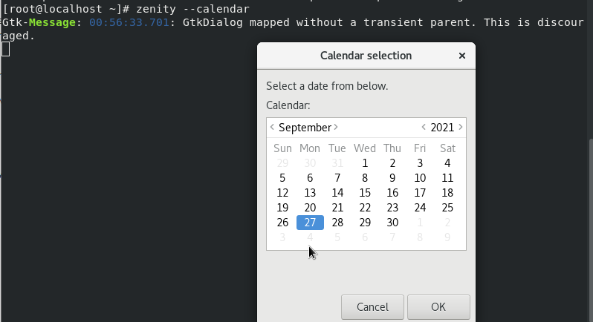

* Take entry from the user in zenity

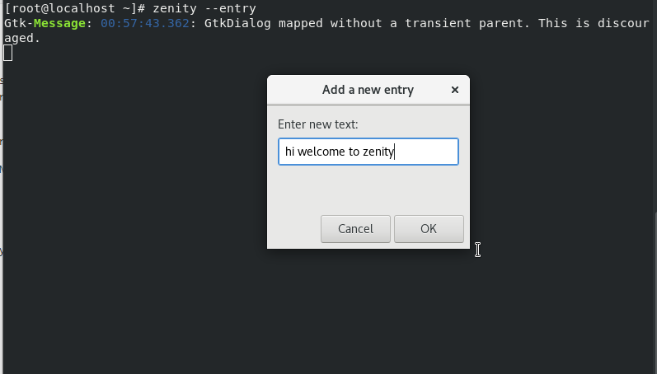

* Use of info in the zenity

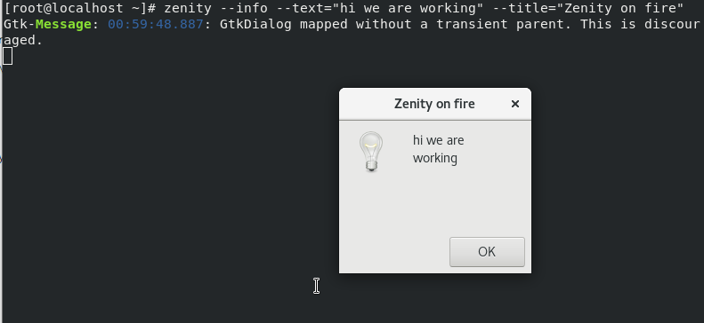

* Create columns in zenity

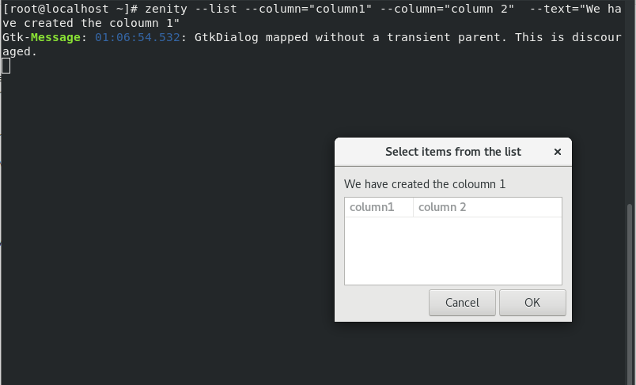

* How to create the progress bar in zenity

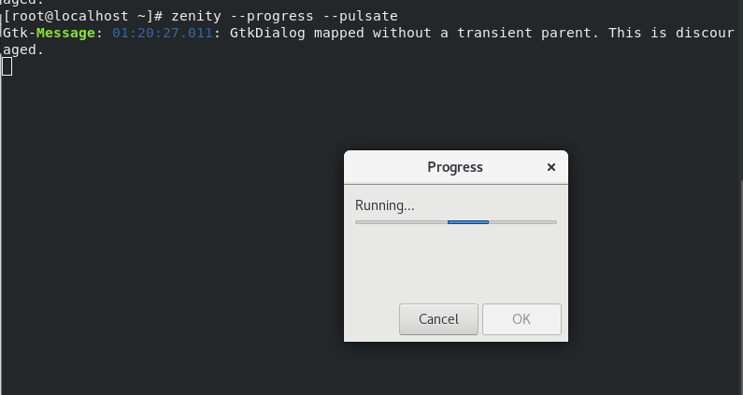

* How to generate a color pallet using zenity

